The Political Image Making
(В: Годишник на департамент Медии и комуникация, С., НБУ, 2022 г.)
Prof. Rossen K. Stoyanov, Ph.D.

„The basic relationship in any society, culture,
subculture or organization is the public image“ (Boulding, 1961/1956:64)

Abstract: Through image it is possible to generate, reinforce, manage and change perceptions, attitudes and attitudes. Image is the process of generating and maintaining a specific public identity formed on the basis of basic positive characteristics of individuality. It is in this sense that image in politics consists of the way people perceive a particular person, party or idea, based on specific personal characteristics and qualities made public through communication, media and technology.
As a communicative structure, the image ensures accuracy in the transmission of information and the coincidence of the sign systems of the communicator and the recipient. The image is a kind of decipherer of the message, translating it into different languages – that of the audience, the events, the visual language.
Keywords: Political communication practices, political image making, reputation management, political campaigning, attitudes, charisma.

The term image is associated with various linguistic, semiotic and psychological definitions – icons, indices and/or symbols. Depending on the focus of the research, its effectiveness is explained by the reflection of ideas, the direction of consciousness or the abstractness of perception. Often representing high-impact stereotypes constructed and derived from established power, images are particularly important for the creation and sustainability of public and private relationships. They form, motivate, shape and dominate thought. It is because of this fact that they also appear as a fundamental element in both the perception of the political and in the shaping of political choices (Edelman, 2001).
Initially, the image was assigned an unflattering local impact as part of the advertising process. Subsequent research and scholarly texts on its creation, influence and effectiveness have placed it in a more prestigious position, for example, according to Boulding, people perceive images as real – they are fundamental to the realisation of processes of personal and social understanding, while playing an integral role in determining human behaviour (Boulding, 1961/1956:64).
Defining image as a fabricated and manipulative notion generated for stakeholders' own purposes is extremely negative, but there is a realistic approach to it. Image is a purposeful communication to influence individual and public attitudes, which must have the ability to persuade and be made up of characteristics capable of evoking trust – realistic, accessible, truthful and verifiable statements, facts, events, attitudes, etc.
The image possesses a conglomerate of properties, including opportunities for personal orientation, positioning, adaptation, and coordination in the space of social relations created through it But most of all, it serves as an attractive force and accentuation of positive at the expense of negative signals and subsequent desired reciprocal perception. Through it it is possible to generate, reinforce, manage and change perceptions, attitudes and attitudes. Image is a process of generating and maintaining a specific public identity formed on the basis of basic positive characteristics of individuality. It is in this sense that image in politics consists of the way people perceive a particular person, party or idea, based on specific personal characteristics and qualities made public through communication, media and technology.
The image is an emotionally decorated image of a politician. In creating and maintaining it, the main task is to evoke positive emotions. An image is an image living in people's perceptions. An image remaining in the mind when the person himself is no longer around. Creating an „image of the candidate“ means to create a specific type of representation on a certain issue. Starting from the visual appeal, such a representation should provoke, add value, positivity and emotionality to the perception of the person. In this sense, an image is a purposeful structured effort to influence and have an emotional-psychological impact on a particular group of people. In fact, pragmatism necessitates the creation of images that often do not possess characteristics and values inherent in the personality, but rather those that have a certain meaning in their addressees while finding „understanding“ and acceptance on their part (Cwalina, & Falkowski, 2014).
The search – and rather the creation of the ideal candidate – must take into account the credibility factor, but it must also take into account the existence of a major competitor. And most of all – with its aspiration to realise the same ideal competitive image (See Figure 1). The strategic goal is to form an image that most closely matches the ideal candidate based on the electorate's voting preferences. The clash of ideas takes place at the intersection of real images, and the clash of images takes place in the image field of the ideal candidate.
Undoubtedly, when it comes to image and its construction in the context of political communication practice, this term is invariably combined with one other – charisma. Even Max Weber introduced the concept of charisma into scientific thinking in his attempt to explain the success of great people. One thing is certain – charisma cannot be acquired. It cannot be learned, it cannot be trained. Charisma appears to some to be a godsend. It is a quality peculiar to a particular personality that is an irresistible pull. Having charisma helps to influence and impact, to inspire and to create faith. Charismatic personalities have not always been or are omniscient. The point is to find them and if they have the defined competencies, expertise, leadership qualities, attitude, erudition, desire, etc., to engage them in the business of politics.
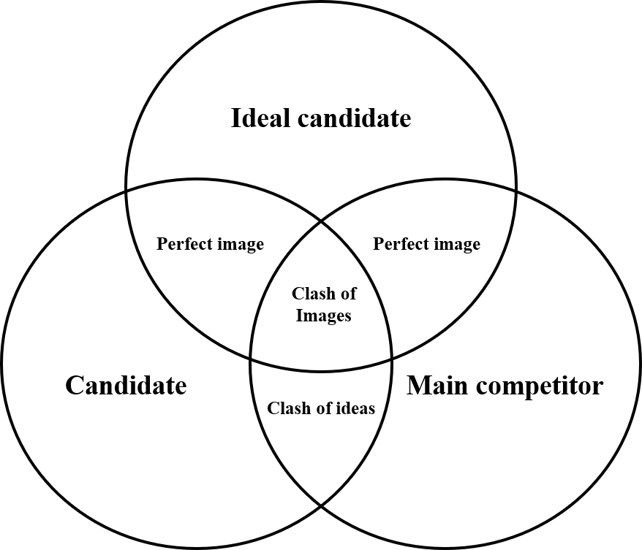

Figure 1
Location of the ideal competitive image

A leader is inextricably linked to his followers, those who like him, vote for him, who follow him. In this sense, the experience of the charismatic is also a conscious or not inner emotional (co)experience of the individual.
Charisma is a personal experience in a group setting
In building the image of the candidate, it is imperative to seek to create the image of the winner, the „father of the nation“. The image may be (Lisovsky, 2000):
- objective or real – the impression of the candidate (his image) that exists in the minds of the voters;
- subjective – the perception of how the candidate and his/her team appear to voters;
- modelable – the image that professionals and the candidate seek to create;
- desirable – the one the candidate wants to have in the eyes of voters;
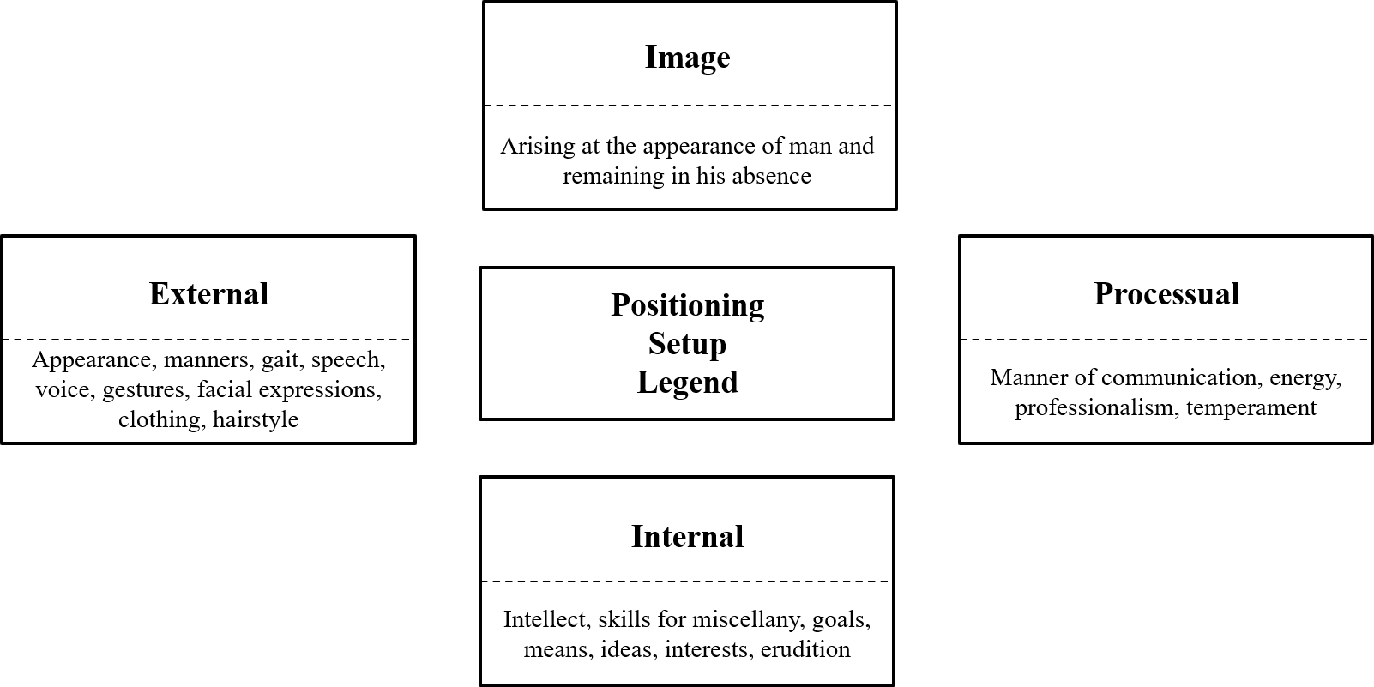
- self-image – based on experience and corresponding self-perceptions of perception.

Figure 2
Structure of the image Potemkina (2006)

Apart from different definitions of what image is, there are also different definitions of its nuances, which are presented in the form of classifications of different types of image. One of the most common, cited and close to practice definitions is that of Jefkins (Jefkins, Baines & Egan, 2004):
- Mirror image – one's own opinion and judgment of how one is perceived by the external environment. An expression of one's own desire. Desired and believed rather than realistic.
- Multiple image – represents the totality of the personal perceptions of those involved in the institution's activities. An extremely subjective notion. It is constructed and developed on the basis of internal organizational work. Acts effectively in building attitudes and attitudes towards own environment.
- Desired image – applicable in a situation of lack of an established image. Depends on what are the goals, essence and ideas of the organization.
- Current image – defined by what people outside the organisation actually know about us at a particular moment. Particularly important point when preparing PR campaigns in advance.
- Optimum image – The best image achievable and consistent with the situation at the time.
- Corporate image – A combination of the current and mirror image of the organisation.
The organization is perceived and presented as an entity. This image is based on the established reputation in society.
Charismatic women in politics:
Catherine the Great, Joan of Arc, Elizabeth I Tudor,
Margaret Thatcher, Benazir Bhutto Madeline Albright, Condoleezza Rice
For political advertising, the most interesting are the objective (current) image, because of the possibility to adjust it in the process of implementation of the advertising strategy, as well as the modellable image that will be transmitted to the audience. For an effective strategy, it is ideal when the modellable image becomes current.
It is also possible to identify five main stages in the construction and functioning of political image:
- Creation – the creation of a political image is defined by three main stages:
a. Creating a skeleton – selecting a direction along which to develop the main narrative (innovator, hero, charismatic unifier, etc.).
b. Creating a biography – often selectively formulating one with a focus on professional and political success, personal and family happiness, etc.
c. Creating a legend (this includes party brands, organization, and ideas).
- Positioning – setting a precedent to not only introduce the new name or candidacy, but to establish it permanently in the minds of the electorate. For this purpose, it is possible to generate various events and pseudo-events.
- Fixation – type, characteristic movements, speech, facial expressions, non-verbal communication. Characterization and differentiation from the surrounding candidates.
- Attack of the competitive image – emphasis and communication on the negative aspects of political competitors. Action characteristic of negative political advertising.
- Maintenance – adequacy to the competitive environment, to reality, to political demand, to conjuncture, to ideological political and party load. Contrasts with opponents and claiming similarity with proven personalities in politics.
In the construction of the advertising political image should be taken into account mainly the moral, intellectual and political qualities, as well as the personal potential of the candidate and the following elements:
- defining the „demand“ and desires of the audience;
- comparing the real qualities of the candidate with the expectations of the audience;
- selecting those characteristics that are „demanded“ by the electorate (they are the basis of the image) – selecting additional characteristics that work in different sign contexts – visual, verbal, event, etc.
The following classification of individual qualities can serve for self-assessment and evaluation by experts (Potemkina, 2006):
- impact of speeches; - memorable appearance; - emotionality; - energy; - argumentativeness; - sincerity; - state of health; - mimicry; - expressiveness of gestures; - timbre of voice;
- hairstyle; - formal dress; - gait; - professionalism; - intellectual level; - originality of thought; - purity of ideas; - goals; - honesty;
- peculiarities of communication; - range of interests; - high self-esteem; - flexibility of thought; - sense of humor; - self-possession; - self-confidence; - ability to listen; - determination; - ability to change;
- teachability; - tactfulness; - belief in the good; - responsibility; - competence; - oratory; - leadership qualities; - life experience; - presence of legend; - ideological commitment; - clarity of thought.

For any politician who wants to be successful, it is necessary to build not just an image, but a modern image. To this end, he needs to cultivate a system of qualities that define his image as modern. Here are some of them (Potemkina, 2006):
- Self-respect based on proven and recognized professionalism.
- Independence (personal, subjective, economic).
- Ability to make decisions independently.
- Romantic style.
- Bright personality.
- Excellent contemporary team.
- Mental and physical health.
- Contemporary prosperous family.
Image represents the public „I“ of a person (Pocheptsov, 2001)
Pocheptsov defined 10 technologies for building an image (Pocheptsov, 2001):
- Categorically distinguishing the given candidate from the competitors.
- Emphasizing the personality characteristics that can represent him and be accepted in the voter's conceptual system as his own.
- Inscribing him in the idea of „leader“, carefully selecting those of his characteristics that correspond to this ideal image.
- Inscribing him in the model of „already realized leader“, because here we operate with the leader as a symbol, not as a real person.
- Inscribing the candidate in the model of the behaviour of an „actor“.
- Using other channels of perception, the main of which appears to be the visual, as more impactful and memorable.
- Active use of accompanying symbolization, in particular in relation to the creation of a visual characteristic of the party (branding, assemblies, parades, etc.).
- Active management of processes.
- Fighting against autonomous flows of information (such as rumours, for example).
- Reliance on symbolization – such as clothes, hairstyle, look, etc.
Building an effective image as part of political communication practices can also be based on one, let's call it, non-standard form of interaction and influence with the society – rumours. By its nature, rumours can also be classified as myths, which emerge as an oral form of communication against the background of the surrounding written, audiovisual, official, formal context. It is a kind of interpretation of reality, and its role is to fill certain gaps and lacks of official information.
Gossip can help to carry out an effective political communication while keeping the real author and sender of the message anonymous. To this end, it is necessary to carry out a „translation“ of the necessary information from official to rumour-specific. In this way, more than one or two rulers have tested public opinion on a topic or on potential future actions. Even rumors appear to be a mandatory component of any crisis communication – precisely because of the almost always occurring crisis in terms of the level and quality of information (Pocheptsov, 2001).
On the other hand, the political space is becoming more and more hostage to the symbolic world we live in. The contemporary politician lives and works in this world and is forced to become a symbol himself. In this, he is obliged to build both himself and the world around his personality – the scheme begins with creating and filtering a past, emphasizing in communication family, sporting passions, hobbies and love of pets, even the measured admission of small weaknesses and mistakes.
Visuality is imposed as a tool to shape public opinion
In 1960, during the Kennedy vs. Nixon election campaign, televised debates in the US upended preconceptions and attitudes. The beginnings of a conceptual shift in the prioritisation of political behaviour, and hence the form, content and channels of communicating the political message. The journalist Joe McGinnis, who covered Richard Nixon's 1968 election campaign, recounts the skill with which Nixon's advisors modelled the candidate's image presented to the American people. In describing these events, McGinnis suggests that television is a powerful means of getting voters to vote not for the candidate himself, but rather for the image of that candidate. Or, as one of Nixon's top image-makers, Roger Ailes, puts it (McGinniss, 2012/1969:155):
„This is the beginning of a whole new concept. It is. This is the way they will be chosen in the future. The next ones have to be actors“.
It is the duty of every communication specialist to define the expectations and „requirements“ of the audience from the very beginning. The next step is to correlate the actual qualities of the candidate with the qualities expected by the audience. Next comes the choice of those characteristics that are demanded by the potential voter (and they are the basis of the image). This is followed by the selection of additional characteristics; the formulation of the constituents of the image and the mapping of the chosen emphases to different sign contexts.
Lisowski defines the following main functions of the image (Lisowski, 2000):
- Nominative – the image designates, differentiates the politician, demonstrates and highlights his merits and distinctive qualities.
- Aesthetic – the image is called to ennoble the impression that the candidate creates in the audience.
- Referential – the image connects the politician and the target audience, responds to the demand of the electorate.
- Communicative – perhaps the most important and constant function of the image.
The communicative properties of the image are the advertising component, which ensures the effectiveness of the information, facilitates its perception by the audience and prepares the ground for the formation of an attitude to choose this particular candidate.
It can definitely be argued that image is not only an element and factor in political advertising, but also a means of psychological influence. Often even a means of psychological processing and manipulation of consciousness. This popular method of influence in political communication practices also contributes to the construction of additional psychological values. Thus, the social significance of the real image is enriched in the process of influential communication. And this applies in full force especially when it comes to negative political advertising. The construction of a negative image quite often uses techniques typical of propaganda, such as:
- Hyperbolization.
- Fear.
- Manipulation.
- Tendentious interpretation.
- One-sidedness, etc.
Both the triggering of stereotypes and the ability to create and use myths play an effective role in the construction – and especially in the realization – of the image. The ability to create a kind of halo around the candidate also ensures his further sacralisation, and hence the „prohibition“ of competitive or oppositional criticism (Lebedev-Lyubimov, 2002).
A specific quality of the image is its dominance operating with compressed instead of the full volume of information. The specificity of image communication lies in the necessity to create messages with the expected reaction of the voter in mind.
The whole spectrum of features included in the image needs to be aggregated in the form of blocks:
- Personal – these are physical, psychophysical features of the politician, character, personality type, individual decision-making style, charisma;
- Social and ideological positions of the leader – attitude to his immediate environment and to different social groups, allies and opponents, status of the personality;
- Symbolic worldview, program and permanent cultural archetypes – associated in the minds of voters with their idea of a leader and leadership.
As a communicative structure, the image ensures accuracy in the transmission of information and the coincidence of the sign systems of the communicator and the recipient. The image is a kind of decipherer of the message, translating it into different languages – that of the audience, the events, the visual language.
Newman and Perloff define image in politics as (Newman & Perloff, 2004:21):
„...the creation of images through the use of visual impressions that are communicated by the candidate's physical presence, his media appearances, and his experience as a political leader, with this information being integrated into the minds of citizens“.
We can identify sincerity and leadership qualities as two key characteristics of an effective image. Leadership, invariably linked to charisma, must be present at all levels of the organisation. It depends on a million little things done with dedication, perseverance and care, but they are all worthless if trust, vision and belief are lacking.
A leader is always a specific person, possessing unique features of his personal biography, character, personal experience. But, on the other hand, leadership is never a solitary occupation. It always takes place in a group, in a community or in a society. And exploring, understanding and managing the leader-image-follower relationship is essential to effectively managing the interaction between politician and constituency. Therefore, in building an effective image, it is necessary to focus on the following leadership traits (Austin & Peters, 1989):
- Intelligence.
- Dominance – chosen by associates, established over opponents.
- Self-confidence – in oneself and one's actions.
- Activeness – with the idea of being proactive.
- Knowledge – political, ideological, about the workings of modernity.
Due to the fact that a political leader is always in the public eye, his image is perceived more fully and in depth when its main elements are accurately defined and when its users are provided with the opportunity to refine, embellish and build upon it. The image is situated between two poles – the ideal (almost deified) and the human. It is a dynamic, ambivalent category, possessing its own rhythm, constantly changing the images embedded in it. Usually associated with the charismatic, the political image is responsible for the need for consolidation, reconstruction and revival, progress, transformation and transition, reform and change in society. Unfortunately, quite often, and mostly due to the unprofessionalism of political consultants, the claiming of political leadership is taken to extremes, through characteristics typical of the deifying image, such as hero, sufferer, indomitable fighter, martyr, enveloped in the ritualistic propaganda high-frequency repetition infinity. And hence its (the image's), but also its „possessor's“ and physical bearer's, designation as a populist leader with a charismatic halo.
A particularly important communicative part of the image is the image of the future included in it. It must be so vivid that it captivates, enchants voters. To bind them to specific personality factors, group relationships, party identification.
Make your product the „protagonist“ of your advertising.
Build on your previous wins (Ogilvy, 2003)
Image is a set of perceptions in society about a particular organization, institution, product or person. It is also ideal because it exists only in people's minds – it is not a fixed attribute of the organization (Dowling, 2005). Image is the evoked impression of an object formed by reminding all communication impressions. In comparison, a brand is an evoked image that is correlated on an emotional level and stimulates loyalty.
There are not a few examples of purposeful intervention of political image-makers in the ways in which a number of heads of state and politicians are presented in the public space. Seeking to „own“ and control the image generated to the maximum extent is also a major goal of political consultants who build and maintain the image of politicians. Whether a president will be photographed fishing naked up to the waist and another playing basketball, whether a prime minister will play a musical instrument or put on boxing gloves, whether a heir to the throne will engage in charity, military work or be seen on the sports field, depends not so much on their personal skills and competencies, but on a deliberate and premeditated strategy to build an effective and impactful, memorable and well-received image in the minds of potential voters, supporters and entourage.
Projecting a working image of a particular politician in the public mind also obliges for maximum control of information in time and space. Not only due to the fact that once the image is generated, it also receives the possibility to be developed and modified depending on the communication channel, the technical means and, above all, depending on the personal interpretation of the communicator, the mediator and the environment, competence and context of its perception. The image can thus also be defined as a system of total communication, precisely because of the provision of harmony and unity between the multitude of individual elements necessary for the effective functioning of the overall positive image of the political philosophy and organization of a political force or candidate, their communicated identifications, symbolism and ideology.
The following problem areas represent a major challenge to the process of forming and implementing an effective and successful image campaign:
- justification and protection from competing political images;
- the preservation of realism of symbolism;
- not allowing the image to become an excessively extraordinary representation;
- preventing it from becoming a passing consumerism in terms of the perceptions of those who consume it;
- its pragmatisation to the level of communication of ideological and political messages.
One of the recipes for successful image building and overcoming the challenges to its effectiveness and vitality is to conduct a permanent campaign that includes all available resources. Maintaining such a campaign should not be an end in itself, but should use the tools of constant media monitoring, public opinion research and adaptation to emerging circumstances and changes in the environment.
The effectiveness of a political image is in direct dependence on the qualities and the real perception of the personality of the candidate. To this must be added the additional effects based on the ways in which the particular politician is represented in the media and public space. And last but not least, what challenges, unresolved problems, crises and competition the political candidate faces and what difficulties he or she has faced and is facing. To be effective, a political image must know:
- voter attitudes;
- voting habits and democratic practices;
- political biases and the existence and level of democratic reflection and competence;
- psychological characteristics and irrational motives in decision-making.

The politician as celebrity.
This phenomenon of modernity is possible not only because of the perception of politicians as stars, but mostly because of the following „objectivities“:
- the emphasis on the popularity (in the context of its contemporary definition and experience) of politics;
- the strong entry into politics of celebrities and „famous“ media figures;
- the so-called political dynasties.
Often at the expense of the seriousness, objectivity and pragmatism characteristic of politics, the world around us provides opportunities for composing, multiplying and transmitting into the public space heuristic signs well received by potential voters. Contemporary voters are viewers, listeners and readers; they are consumers of communications and technology. In this sense, their decisions are increasingly based on the media and communication experiences generated. Personality characteristics, such as character traits, can also be attributed to symbolic cues, but most of all, the specific visual representation. It is these signs that can form impressions and beliefs in the electorate, even about the (non-)existing knowledge and skills of the political candidate. The impact of such parasocial connections influencing public opinion can be analogized to that of the compelling magnetism of charisma.
Rojek defines three types of celebrity (Rojek, 2001):
- Celebrity by definition (ascribed selectivity) – by bloodline and having inherited the celebrity of their parents (descendants of royalty, aristocracy, political, industrial and cultural figures...). Such personalities in themselves have a superior social status, which implies an unchanging media interest.
- Acquired celebrity (achieved selectivity) – personalities who due to their extraordinary qualities, skills, competences have won their „honorary“ place in the public space and the minds and hearts of the people. Acquired celebrity personalities are particularly curious to the media because they are or can be presented in an extremely contrasting way. On the one hand, as an example and role model, and on the other – their notoriety to be generated because of their infamy. They can illustrate the fulfilment of a life dream in a given society or the downfall – all scripted and dramaturgically appropriate events.
- Implied celebrity (attributed selectivity) – where acquired celebrity is not the result of special talents or skills, but rather appears to be the result of a concentrated presentation of a persona claimed as remarkable or exceptional through the media as cultural mediators (this includes so-called stars of reality television formats, for example). Characterized by the fleeting nature of entertainment or scandal and the consumption of mass culture.
In contemporary political life we can define representatives of all three types of celebrity.
The pragmatism of politics obliges the use
of the „most acceptable“ political image

Image and reputation management.
A sustainable image is one of the prerequisites for achieving a positive reputation. It is achieved by the implementation of a positive permanent campaign, the main element being the systematic way of building it. The comparison of image with reputation will enable us to define some subtler nuances as well as differences. If we can imagine the life of an organization or a long-term active public appearance of a person as a film strip, then reputation will be the impression and opinion built as a result of the overall familiarity with the film. At the same time, the image will be the perception built on the basis of a single frame of that tape.
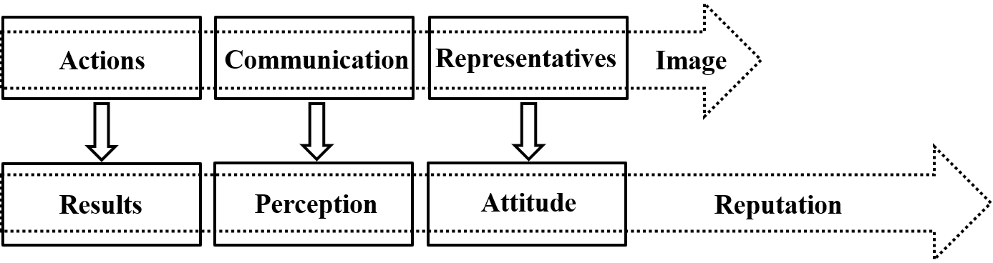

Figure 3
Individual stages and links between image and reputation

Reputation is a long-term and purposefully built relationship to integrity, carried out on the basis of strategic communication with a biography and a future, while image is a campaigning effort. It is "the overall perception of the main aspects of the company's activities to date and expectations for the future, which reflects the overall attractiveness in relation to its leading competitors (Lehtonen, 2006).
Reputation is an asset of an intangible nature. For any organization, reputation represents a kind of capital - a value formed not only on the basis of trust with the organization's significant publics, but also on the basis of their quality, long-term, predictability, sustainability, and the continuously built and maintained positive view of the organization's future (Lehtonen, 2006).
Reputation, in contrast to chaotically formed and emotion-based stereotypes for example, is strategically conditioned, but the idea is to make a complete smooth fusion between them. Where this is not possible - reputation should be made to fit in as closely as possible with existing stereotypes, and precisely to optimise emotional evaluations and bonds between politician and voter. Of course, in the context of political competition, personal political reputation is represented by:
- the power of the personality, as its main building factor;
- the creation of a „legend“, as a subsequent, but also possible for dynamic correction, its interpretation.

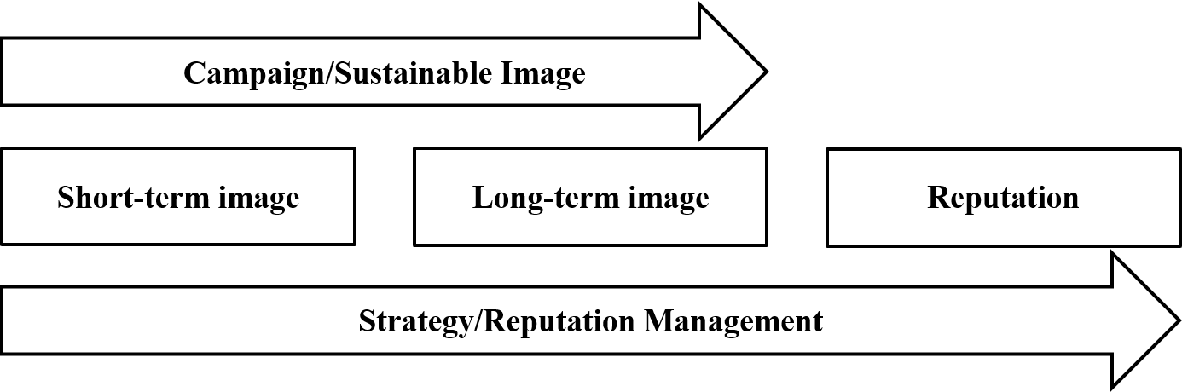

Figure 4
Essential characteristics of image and reputation

There are three main types of party image:
- Brand image – is essentially the political brand. As a bearer of mythological character brand image contains in itself symbolism, psychological value and identification characteristic.
- Institutional image – impressions, stereotypical perceptions, attitudes, etc. towards a given political party, including the functioning of party elements, members, advocates and representatives at local and national levels. Historicity, memory and the possibility and ability to narrate them play an undoubted role here.
- The image of ideas – it is the stated and defended political values that enhance the subjective evaluation of politicians' activities, their programmes and promises. Safety, peace, prosperity, order, justice, etc.
- Personal image – the individual evaluation and emphasis on the candidate's positive characteristics. This can include his or her personal success (power, professional success, personal and family happiness) and personal potential, as well as emphasizing his or her uniqueness as a leader. A key place to position communication „covering up“ the candidate's weaknesses.
In the preparation of any image campaign, three main analyses take place:
- Familiarity analysis.
- Popularity analysis.
- Personality or corporate characteristics analysis.
As a consequence of the results of these analyses and their interpretation, it is necessary to take action on the design and implementation of different types of campaigns:

- The promotion campaign is implemented in the case of a candidate who is still not so well known in the political, but especially in the public space.
- Another type of campaign is the positioning campaign – it is characteristic of the second stage in the case of a new candidate and as an option for repositioning or positioning on a fundamentally new issue or situation of an already known candidate.
- Mythologizing campaign – necessary in any case of candidacy for a political career.
Only leaders with adequate self-assessment have a better chance of successfully creating, positioning, and effectively influencing their political image. The need for prior analysis is imperative – at the very least to answer the following causally related questions:
- Is there an established image of the candidate, respectively the party, the idea, etc. After answering this question, a campaign of a different kind is implemented.
- If there is an existing image - to what extent it is positive or negative and above all is it necessary to change, develop or maintain it.
- Given that there is a working image and the need for intervention and change is identified, to what extent will it be implemented – overall, individual elements, time, place, dynamics, type and volume of these changes.
The formation of the image of the political leader is a consequence of a careful study of the expected qualities, characteristics and personal abilities of the candidate, the choice of technology for the development of a strategic image, as well as communication approaches and media channels for its presentation in the public space. Last but not least, a successful image campaign is mediated by opinion leaders, confidants and informal leaders in direct contact and in informal communication with potential voters, and ultimately the candidate himself perceives and animates this image in practice in his daily encounters with voters.
In addition to the verbal image and non-verbal communication of the candidates, we can add the voters' evaluation of the visual image of the candidate. The perceived belief among researchers and practitioners is that the nonverbal image of political candidates also influences political decision making. The analysis of only photographic images of political candidates' faces provides sufficient interpretative material, consequently it is possible to draw workable conclusions. The study relates to the assessment of the following four distinctive features (Mattes et al., 2010):
- Competence.
- Attractiveness.
- Cunning/deceitfulness/cunning.
- Threat.
After careful analysis of the results obtained from the respondents and comparing the submitted answers with the election results, Mates and company, also referring to Todorov's research (Todorov et al., 2003; 2005; 2006), concluded that the candidates listed as threatening lost 65% of the elections. On the other hand, the positive correlation between impressions of competence and actual electoral outcomes is confirmed. The authors of the study found it a surprising pattern that despite their attractive appearance, if candidates appear politically incompetent, they lose elections. The conclusion is that factors such as the nonverbal facial representations of political candidates significantly influence voters' decision making in actual elections.
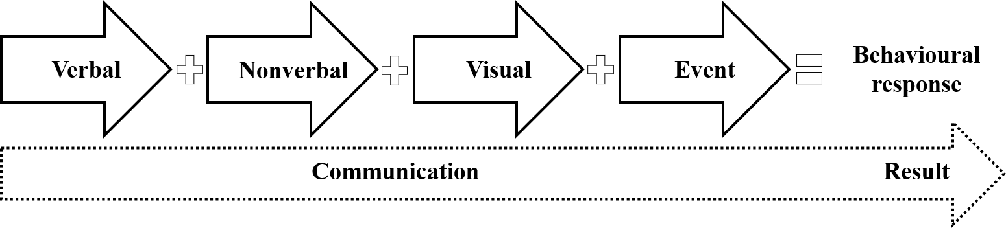

Figure 5
Behavioural response as a result of persuasive communication

But when it comes to image, one should always make the caveat that it is not just an impression and a reflection of a candidate's appearance. The complex process of image-building is essential when it comes to political advertising. Modern political campaigns include advertising in the composition of PR communication. Whillock argues that image building is crucial in the contemporary world of political campaigns because of the general lack of motivation observed in audiences to research and actively seek out the information they need to make their decision, consequently exercising their right to vote (Whillock, 1991).
At the same time, Nimmo's analysis of the role of image building in political campaigns links political advertising and political public relations (Nimmo, 1976:7):
„In general, modern image campaigns are carefully orchestrated combinations of advertising and information implemented through any and all media - radio, television, newspapers, brochures, mail, billboards, etc.“
According to Nimmo, images are reflections of reality that carry information about things that are outside the mind - they are generalized reflections of things, consisting for the most part of what we feel about a product rather than what we know about it.

A candidate's position on controversial issues is important and perhaps the most important factor in voting and choosing | Economic factors are the most important determinants of voting decisions | Holbrook (1994)
A candidate's positions on controversial issues are unimportant because voters place far more weight on other aspects of candidates | The personal characteristics of the candidate are at the heart of the electoral choice and have relatively more weight and influence in shaping the final voting choice | Funk (1996)
A candidate's position on controversial issues, as well as the candidate's characteristics, are important in the process of informing voters and making the decision to elect and vote | Positive balance of impact between personal characteristics and perception on the one hand, and retrospective evaluation, ideological load and specific actions and attitudes towards political and other controversial issues on the other | Flanigan & Zingale (1994)
Table 1
Main strands analysing factors for political decision making

The media imposed a kind of redesign of political identity and political personality in order to maximize the impact of produced images – this change is more on the individual image visual basis at the expense of ideological, ideological, party or programmatic one. Thus, the perception, analysis and interpretation of the mediated political takes place on the basis of communicated images and pictures rather than on the basis of political arguments and policies.
The political image relates to existing, created or changing cognitive representations that serve to summarize, organize and order political demands. Thus defined, the virtual manipulative psychological image appears as a construct of thought, and in this sense, it is both ideal and particularly difficult to deny, modify, or change, as it also becomes part of the evaluative and value system of individuals. Citizens' overall political perception is a process that is mediated by the construction of ideas about political processes, political candidates and politics in general. This process is distinguished by:
- Semantic interpretation of power and leadership, at the expense of their objective representation, reflection and perception.
- Synthesis between the cognitive and emotional components of perception.
- Mediation of mass media.
In this sense, the political image is an image that is a set of perceptions formed in the minds of individuals and the impressions created on their basis, simultaneously playing the role of both a reflection of reality and a projection of expectations.

Individual qualities |  | Will, conviction and confidence | Faith, optimism and pragmatism | Appearance and attractiveness | Communication skills
Social qualities | Moral and Ethical | Excusability and fairness | Honesty and integrity | Dedication and selflessness | Charismatic and active
Social qualities | Politically and professionally | Competence and expertise | Professionalism and great experience | Programme and ideas | Social status
Symbolically qualities | Positive images | Messiah and miracle worker | Fighter and winner | Manager and statesman | Innovator, new, reformer
Symbolically qualities | Modern publicity | Prominence and recognition | Approval and success | Actor and showman | Media charisma
Table 2
Qualities that influence the formation and effectiveness of political image

The reflection of the expectations of pre-specified groups in the image created is as logical as it is useful in an image campaign. Undoubtedly, this process must also take into account the presence, level or lack of political culture of the players involved, the „habituation“ of perceptions, reflexivity and proactivity, political awareness, etc. Seguela recommends the observance of eight basic principles for a successful image (Seguela, 1999:68):
- Vote for a person, not a party.
- Vote for an idea, not an ideology.
- Vote for a future, not a past.
- Vote for a social, not a political image.
- Vote for a man of legend, not mediocrity.
- Vote for destiny, not routine.
- Vote for a winner, not a loser. 8 Vote for real, not imagined values.
The very core of the political image is the legend. It is what allows a politician to become and remain popular, memorable and easily recognizable. The legend is an artificially generated and imputed subconscious construct, formed on the basis of a general impression of a particular personality. A vital, well-thought-out and functioning legend creates favourable conditions for positive publicity of the political candidate despite certain personal mistakes, statements or actions, as well as despite the stereotyping negative and biased perception of dealing with politics. The stigmas for creating a legend are:
- Key moments in the candidate's biography.
- Characteristic personal qualities – appearance, appearance, behavior and specific actions, events and incidents.
- Advocacy (and in the best case authorship) of an idea – a political idea, a mission, the big thing...
Sense of self, successful realization, high intelligence, values, professionalism and rationality are all possible building blocks of the legend. In addition to these can be added the advocacy of a clear, specific and reasoned position on specific issues.

Infectiousness of speeches | Yes/Assessment | Breadth of interests | Not/Assessment
Memorable appearance | Not/Assessment | Visoka self-esteem | Yes/Assessment
Emotionality | … | Flexibility of judgement | …
Energetic | … | Sense of humour | …
Reasonability | … | Composure | …
Sincerity | … | Self-confidence | …
Personal health | … | Ability to listen | …
Mimic | … | Determination | …
Expressiveness of gestures | … | Ability to change | …
Timbre of voice | … | Learnability | …
Clothing, hairstyle, style | … | Tactfulness | …
Time control, | … | Faith in the good | …
thoughts, goals and emotions | … | Responsibility | …
Gait, handshake, posture | … | Competence | …
Professionalism | … | Oratory | …
Intellectual level | … | Leadership qualities | …
Originality of reasoning | … | Life experience | …
Purity of thought | … | Presence of legend | …
Objectives | … | Intensity of ideas | …
Worthy means | … | Clarity of reasoning | …
Table 3
Possible matrix for assessing the structure
of political image by main qualities
According to Potemkina (2006)

After all, in the general process of perceiving and evaluating a policy, a special place is given to the impression it reproduces in the public space. Undoubtedly, in the technological, media and communication age, in the age of visuality, symbolism and publicity, the importance of the impact of this 'intentional' impression is growing immensely. The image of a politician is perceived as it is presented in the media public space and in no other way.
The world, according to persuasive communication, has never been more positive, more successful, more colourful and more diverse. This applies in full force to the images of political candidates presented as real. Today, reality is being replaced by a digital virtuality that, based on visuals, is also becoming a virtuality of ideas, promises and commitments, and persuasive communication is becoming the information we all need, expect, seek and consume to explain and order the world around us. In this way, the image as a virtual construct and a tool for purposeful influence also becomes a primary means of manipulating political reality.
The political image is an invariable two-way communication between politicians (the political leader) and the public (the voter), its main characteristic being its integral integrity. The creation, promotion, maintenance and competitiveness of the political image also make it an essential component of publicity in politics.

Notes:
- Austin, Nancy, Thomas J. Peters (1989). A Passion for Excellence: The Leadership Difference, Grand Central Publishing, https://goo.gl/yZRbSA.
- Boulding, Kenneth E. (1961/1956). The Image: Knowledge In Life and Society, University of Michigan Press, https://goo.gl/v0eejB.
- Cwalina, Wojciech, Andrzej Falkowski (2014). Political Branding Political Candidates Positioning Based On Inter-Object Associative Affinity Index, In: Journal of Political Marketing, (12/2014), pp. 152-174.
- Douling, Gream (2005). Sazdavane na korporativna reputatsia: identichnost, imidzh, predstavyane, S., Roy Komyunikeyshan.
- Edelman, Murray (2001). The Politics of Misinformation, Cambridge University Press.
- Jefkins, Frank, Paul Baines, John Egan (2004). Public Relations. Contemporary Issues and Techniques, Oxford, Elsevier Butterworth-Heinemann.
- Lebedev-Lyubimov, A. (2002). Psihologia reklami, Piter, Sankt-Peterburg.
- Lisovskiy S.F. (2000). Politicheskaya reklama, M., IVTs Marketing.
- McGinniss, Joe (2012/1969). The Selling of the President, Joemac Inc., https://goo.gl/yuu3d9.
- Newman, Bruce I., Richard M. Perloff (2004). Political Marketing: Theory, Research, and Applications, In: Handbook of Political Communication Research, (ed.) Lynda Lee Kaid, Lawrence Erlbaum Associates Publishers, https://goo.gl/IaP6TW.
- Ogilvy, David (2003). Ogilvy On Advertising, Перевод с английского А. Гостева и Т. Новиковой, ООО Издательство Эксмо.
- Pocheptsov, Georgiy (2001). Professia: imidzhmeyker, Nauka, Sankt-Peterburg.
- Potemkina, O.F. (2006). Imidzh politicheskogo lidera, M., Moskovskiy gosudarstvennыy universitet kulyturы i iskusstv.
- Rojek, Chris (2001). Celebrity, Reaktion Book, https://goo.gl/TFRR0w.
- Lehtonen, Ya. (2006). Riskove na publichnostta, S., Roy Komyunikeyshan.
- Mattes, Kyle, Michael Spezio, Hackjin Kim, Alexander Todorov, Ralph Adolphs, R. Michael Alvarez (2010). Predicting Election Outcomes from Positive and Negative Trait Assessments of Candidate Images, In: Political Psychology, Vol. 31, No. 1 (2010), Wiley Periodicals, Inc., Blackwell Publishing Limited, pp. 41-58.
- Nimmo, Dan D. (1976). Candidates and Their Images: Concepts, Methods, and Findings, Goodyear Publishing Company, https://goo.gl/tSFWqM.
- Seguela, Jacques (1999). National Characteristics of Hunting for Votes. Eight Lessons for a Presidential Candidate, Moscow.
- Todorov, A., Mandisodza, A. N., Goren, A., & Hall, C. C. (2005). Inferences of Competence from Faces Predict Election Outcomes, Science, 308, pp. 1623-1626.
- Whillock, Rita Kirk (1991). Political Empiricism: Communication Strategies In State and Regional Elections, Praeger, https://goo.gl/ZYrT4l.

The Christomatic example of such family political clans is the US political practice – the Kennedy clan and the Bush family. Although placed in different political conditions and circumstances, political dynasties exist in Bulgaria – Zhivkovs, Bokovs, Pirinskis, Stanishevs, Terzievs, etc. Author’s note.

